Use these or those depending on distance^{[1]}.
Use these when something is nearby.
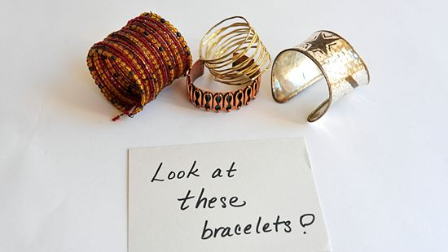
  - These books on the shelf next to me belong to Rajeev.
  - Look at all these bracelets on my wrist!
  - Who put these cupcakes in the refrigerator?
Use those when something is relatively far away^{[2]}.
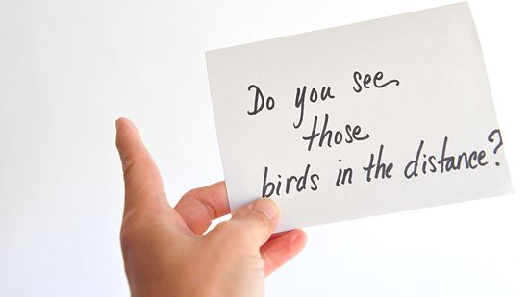
  - Those mountains look really small from here.
  - Could you hand me those boxes on the other side of the room?
  - Why haven't those scientists at NASA found extraterrestrial life?

Use these or those depending on whether something is plural or singular.
These is the plural form of this.
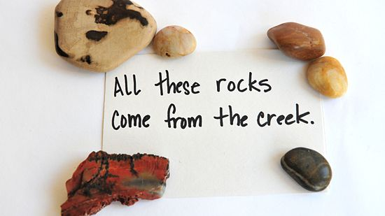
  - Singluar: This book (1 book) on the shelf next to me belongs to Rajeev.
  - Plural: These books (5 books) on the shelf next to me belong to Rajeev.
  - Singular: Look at this bracelet (1 bracelet) on my wrist!
  - Plural: Look at all these bracelets (10 bracelets) on my wrist!
  - Singular: Who put this cupcake (1 cupcake) in the refrigerator?
  - Plural: Who put these cupcakes (12 cupcakes) in the refrigerator?
Those is the plural form of that.
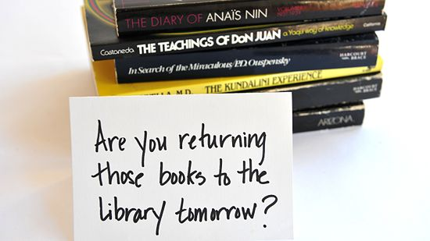
  - Singular: That mountain (1 mountain) looks really small from here.
  - Plural: Those mountains (100 mountains) look really small from here.
  - Singular: Could you hand me that box (1 box) on the other side of the room?
  - Plural: Could you hand me those boxes (5 boxes) on the other side of the room?
  - Singular: Why hasn't that scientist (1 scientist) at NASA found extraterrestrial life?
  - Plural: Why haven't those scientists (200 scientists) at NASA found extraterrestrial life?

Use these or those depending on time.^{[3]}
Use these when something is happening in the present, has happened in the recent past, or will happen in the near future.
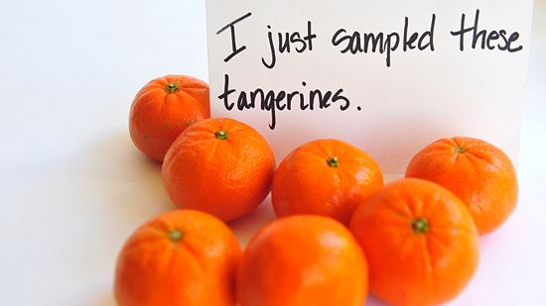
  - These shows I've been watching are absolutely extraordinary.
  - Have you see these letters to the editor in today's news?
  - Why don't you use her ideas in these events later today?
- 2Use those when something has happened in the relatively distant past or will happen in the relatively distant future.
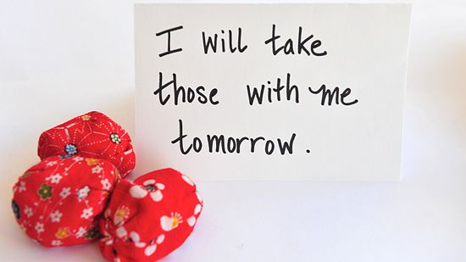
  - Those shows I watched last week were absolutely extraordinary.
  - Did you see those letters to the editor in yesterday's news?
  - Why don't you use her ideas in those events tomorrow?

Use these or those to replace a noun.
Use these to replace nouns that are nearby in space and time.
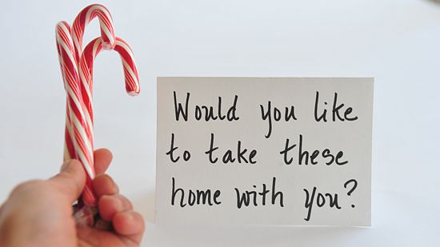
  - I'm holding three chocolate bars. Do you want all of these? (These replaces chocolate bars.)
  - Would you like to borrow some books? Here, take these. (These replaces books.)
  - These are so beautiful! Thank you for the flowers. (These replaces flowers.)
- 2Use "those" to replace nouns that are farther away in space and time.
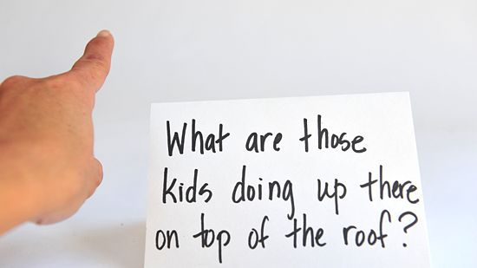
  - That man over there is holding three chocolate bars. Do you want all of those? (Those replaces chocolate bars.)
  - Would you like to borrow some books ? Take those over there on the shelf. (Those replaces books.)
  - Those were so beautiful! Thank you for the flowers you gave me yesterday. (Those replaces flowers.)

Demonstratives are used to point out a particular item. They are as follows:
This (indicates something close to the speaker)
That (indicates something away from the speaker)
These (indicates some things close to the speaker)
Those (indicates some things away from the speaker)

Example:
A: What is this? (pointing to something held in the speaker's hand or near the speaker)
B: A pencil.
A: What is that? (pointing to something at a distance from the speaker)
B: A tree.
Remember that demonstratives are used in reference to the speaker. (What is near "you" may not be near "me" and vice versa.)
A: What's that you're holding?
B: This is an egg. Here, catch!
A: Oops.
B: That's a mess.
A: What are these (holding up a pair of slippers)
B: Those are slippers.
Be sure to use this/that with singular and non-count nouns and these/those with count nouns.
This orange is sour. |  | These oranges are sweet.
That truck is full. |  | Those trucks are empty.
This milk is fresh.
Sometimes demonstratives can be used as pronouns (to refer to a particular noun.)
Give me that! |  | Whose are these?
Give me that (spoon). |  | Whose are these (socks)?
This and that can also be used with one. However, these and those are more commonly used alone.
I want this one. |  | I want these. (not these ones)
I'll take that one. |  | I'll take those.
On the telephone, this and that are used differently in British and American English to identify callers.

Example:
Receiver : |  | Hello.
Caller : |  | I was wondering if you would be interested in buying . . .
Receiver : |  | Who is this? (American)
 |  | Who is that? (British)
 |  | (Both expressions are used to ask the caller to identify himself/herself.)
Caller : |  | This is Mr. Fuller from the Acme Brush Company.
 |  | (Same for both British and American English)
Caller : |  | Hi Jack. Long time no see!
Receiver : |  | Is this Bob? What a surprise! (American)
 |  | Is that Bob? What a surprise! (British)

